# 2.0 System Architecture

## 2.1 System Overview

This Online Showroom System of Lorbek cars is a Complete System designed by Auspal Group as per the demand from the client side(Lorbek Cars). This web-based System Provide Customers and Admin a excellent experience with advanced features, Like Powerful search ability for Loans, Cars, Customers, and Booking. Primarily, all transactions are executed in offline mode, ensuring data security for car details, payment processing, and modifications. The system manages and tracks all the critical information such as payments, insurance, bookings, and customer data, providing a centralized hub for efficient resource management. Highlighting user-friendliness, the interface validates fields to prevent the entry of invalid values and ask the users to input the valid values, and it make possible to the generation of detailed reports on cars, payments, and insurance. Users can easily export data in various formats, including PDF, Excel, and CSV, Increasing Availability, and information sharing. With modules dedicated to administrative tasks, filtering reports, and user management, the system aims to tackle challenges inherent in manual processes, offering a secure, reliable, and error-free environment for Lorbek's Car Showroom operations.

## 2.2 System Architecture Overview

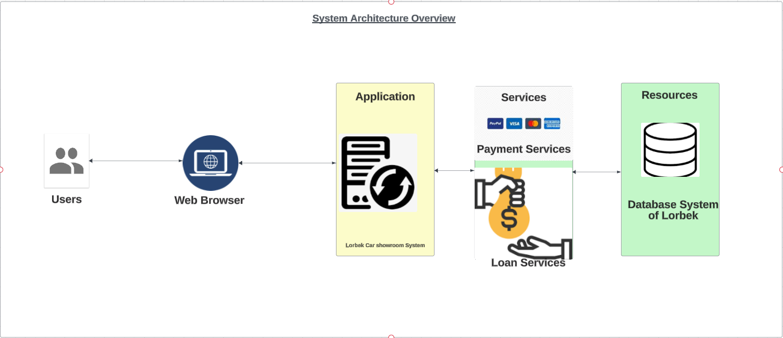

Fig 1: System Architecture

The Lorbek Car show room system has a strong and user-friendly architecture, delivering a smooth and secure experience for its customers and admin. Users navigate the system using web browsers, which provide an easy interface for browsing. The application layer is a critical component that manages user requests and serves as a link between the web browser and other services. This layer coordinates services including automobile browsing, inventory management, and transaction processing. Through bidirectional connections, the system interfaces with various payment systems such as Visa, MasterCard, and PayPal, ensuring a safe and quick financial transaction procedure. Additionally, the architecture includes loan services, which create interfaces with other financial institutions to simplify loan approvals and processing. A reliable database system saves and manages critical data about automobiles, inventories, user profiles, and transactions. This relational database provides data integrity and scalability for the whole system. Lorbek's modular and flexible architecture, which divides the system into distinct layers for user interaction, application logic, and data storage, allows for easier maintenance, updates, and future expansions while providing a streamlined experience for users interacting with the car showroom system.

## 2.3 Hardware components

|  |  |  |
| --- | --- | --- |
| SN | Hardware Component | Description |
|  | Users Devices | 1. Intel core i5 or equivalent 2. Ram minimum 8GB 3. Processing power (3.8 GHz plus) 4. Storage (256 GB Plus) |
|  | Firewalls | Cisco/Fortinet |
|  | Web server | 1. Intel Xeon with Multi-core Processor 2. Ample RAM (more than 32 Gb) 3. SSD(Teamgroup Cardea Z540/ Addlink A93) 4. Network interfaces with enough bandwidth. |
|  | Database Server | 1. Intel Xeon 2. Ram 32 GB or more 3. SSD/HDDs (Addlink A93) |
|  | Routers and switches | 1. Routers: Zyxel SCR 50AXE /Reyee RG-E5. 2. Switches: Cisco SG350-10P /D-Link DGS-1100-08P |

## 2.4 Software components

Along with the hardware we must make sure that all of the software that we are going to use in Lorbek online system are compatible with each other and they are latest too.

|  |  |  |
| --- | --- | --- |
| S.N | Software | Description |
|  | Operating system | Windows, Linux, MAC, Android, IOS |
|  | Web Server | Apache, MySQL for Hosting the System |
|  | Lucid chart | For showing Functional view of the system |
|  | Balsamic Cloud | Ui Wireframes |
|  | Dreamweaver | For writing and editing HTML, CSS, PHP codes. |
|  | Web Browser | Safari, Firefox, Google Chrome, Microsoft Edge |

## Logical View of the System

**Fig: Logical View of the System**

The Lorbek car Show room system's logical view is organised into three logical levels, allowing for a complete and secure operating framework. The exterior layer, which serves as the system's interface, communicates smoothly with both clients and admin. Bidirectional arrows shows dynamic interaction between users and the system, Highlighting a responsive and interactive experience. This layer not only meets the different demands of users browsing the car showroom, but it also offers admin with the tools and interfaces required for effective system administration. Users begin activities through this exterior layer, while admin monitor and maintain the system, serving as important link between end users and the system's basic features.

The conceptual layer has two critical components: the security layer and a web server. The bidirectional arrows that connect the exterior and conceptual levels represent the strong link between user interactions and the underlying system logic. The security layer protects the integrity and confidentiality of data transmitted between users and the system by establishing safeguards against unauthorised access or harmful activity. Concurrently, the web server at this phase receives user requests, performs business logic, and generates dynamic web pages. This bidirectional relationship emphasises the critical interplay between user interactions at the exterior layer and data security at the conceptual level. Together, these layers form a dynamic and secure environment that balances user interaction with powerful system operation.

Finally, the Lorbek system's data layer serves as its primary basis. Bidirectional arrows connect the conceptual layer to the data layer, demonstrating the continuous exchange of information between system logic and the underlying databases. Separate databases for customers and administrators are linked together using bidirectional arrows pointing to the main database. This extensive web of links guarantees that user-specific data is effectively stored, accessed, and updated, demonstrating a well-organized and scalable data architecture. The Lorbek Car showroom system is powered by the logical view, which has three interconnected levels and is user-centric, secure, and data-driven.

## 2.6 Functional view of the system

Based on the Functional Requirements of Lorbek Car showroom Functional View of the system is presented below:

### Customer:

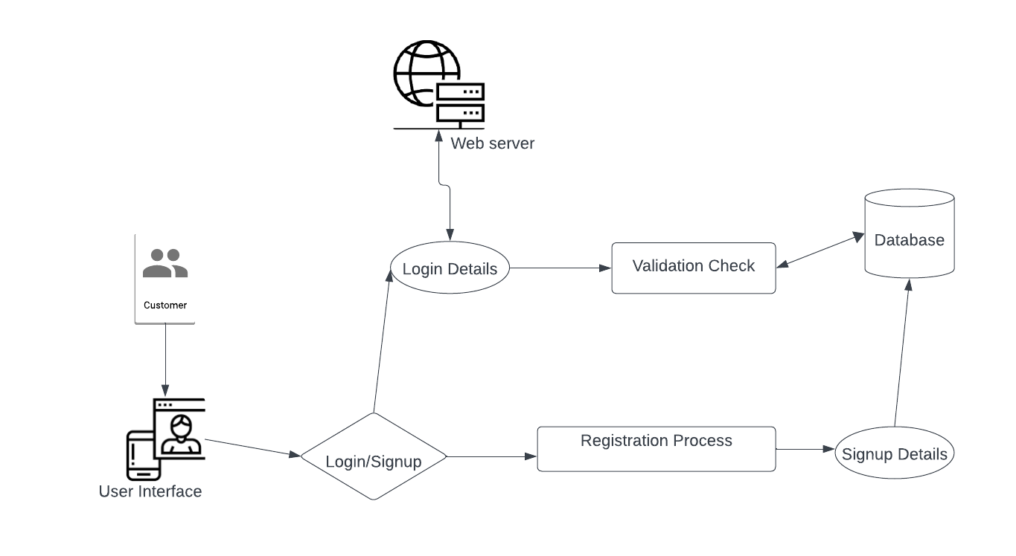

Fig: Customer Login & Signup

Fig: Car Search Options

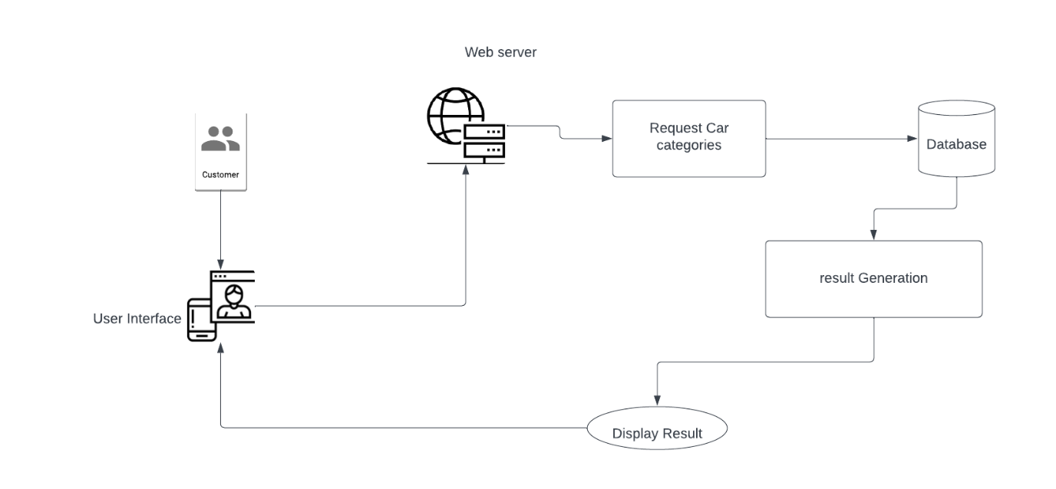

Fig: View Car categories

Fig: Vehicle Information Viewing

Fig: Watch Video

Fig: Making Purchase

Fig: Loan Application Creating

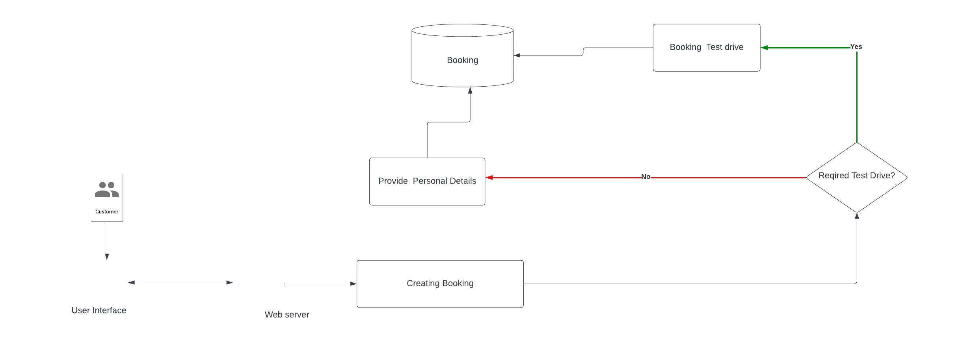

Fig: Creating Booking

Fig: Managing Customer Profile

**Fig: Creating Payment**

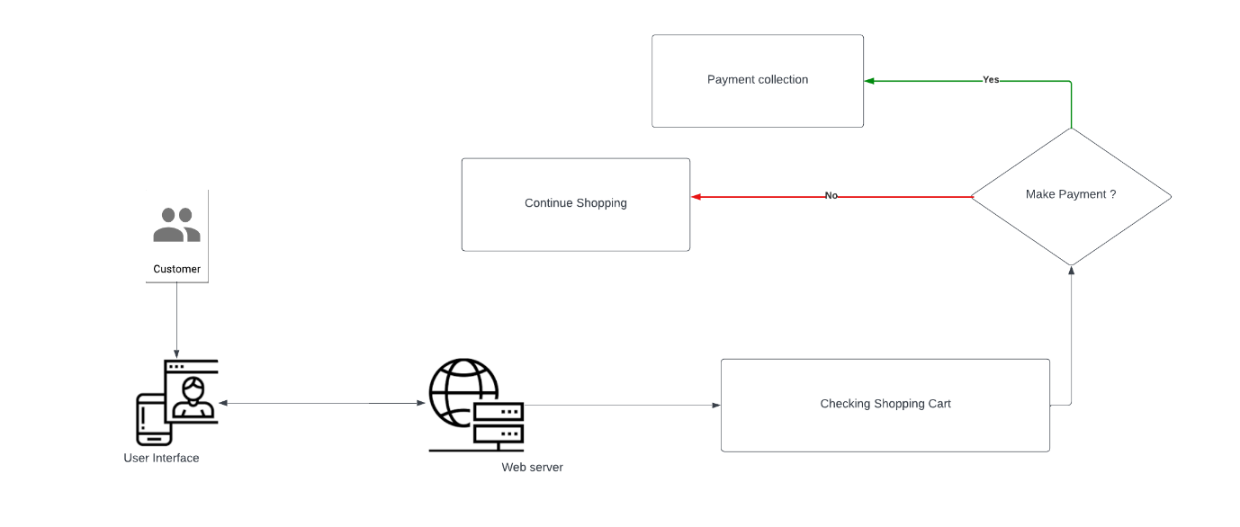

**Fig: View Shopping Cart**

**Fig: Create Feedback And reviews.**

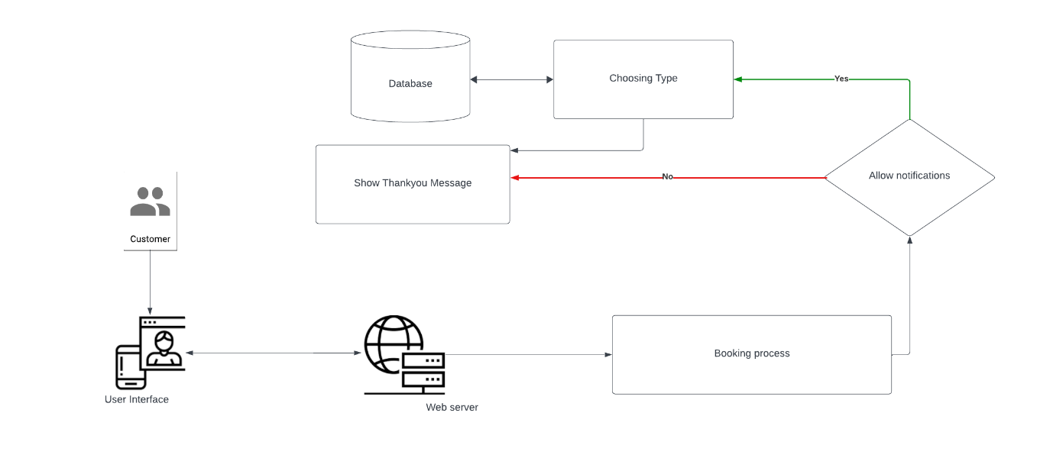

**Fig: Setting Notification Alert**

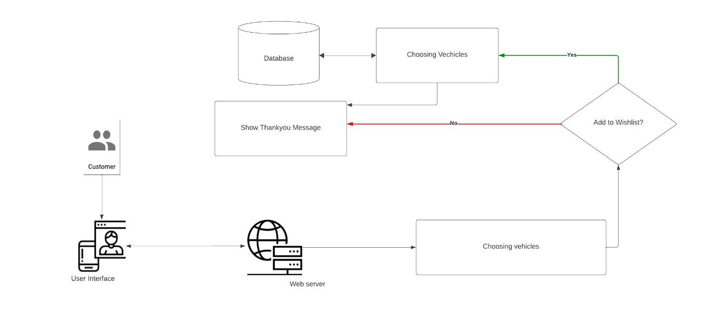

**Fig: Adding to Wishlist**

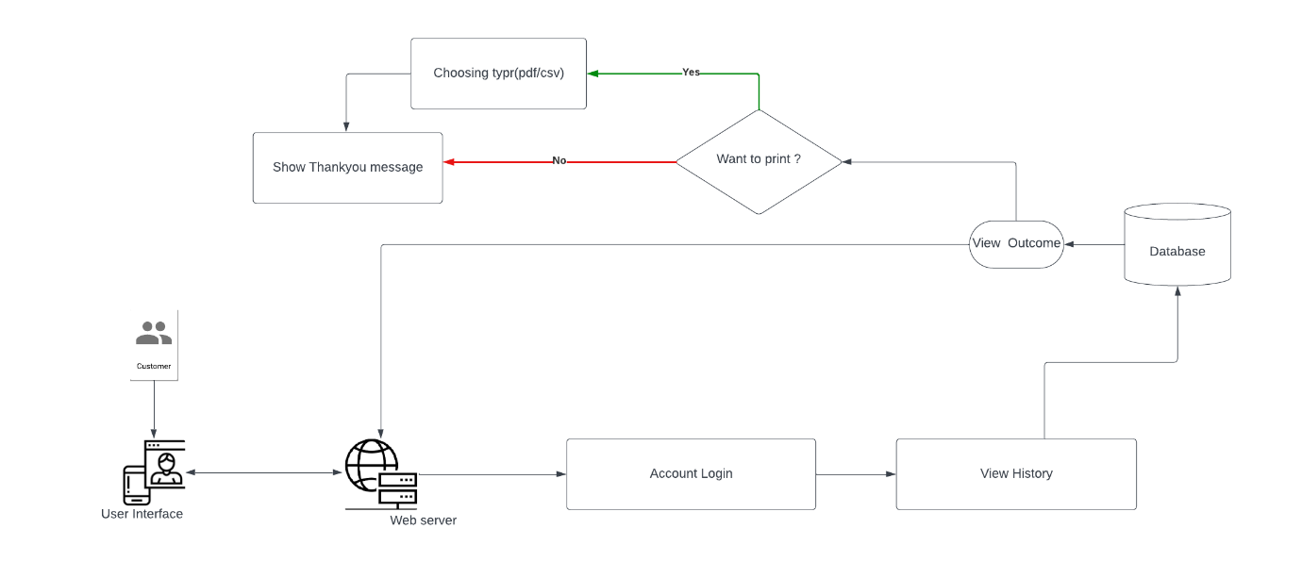

**Fig: Viewing History and Records**

**Fig: Using Price Calculator**

**Fig: Making Pre-order/ Reserve Request**

1. Lorbek database with all Tables and entities

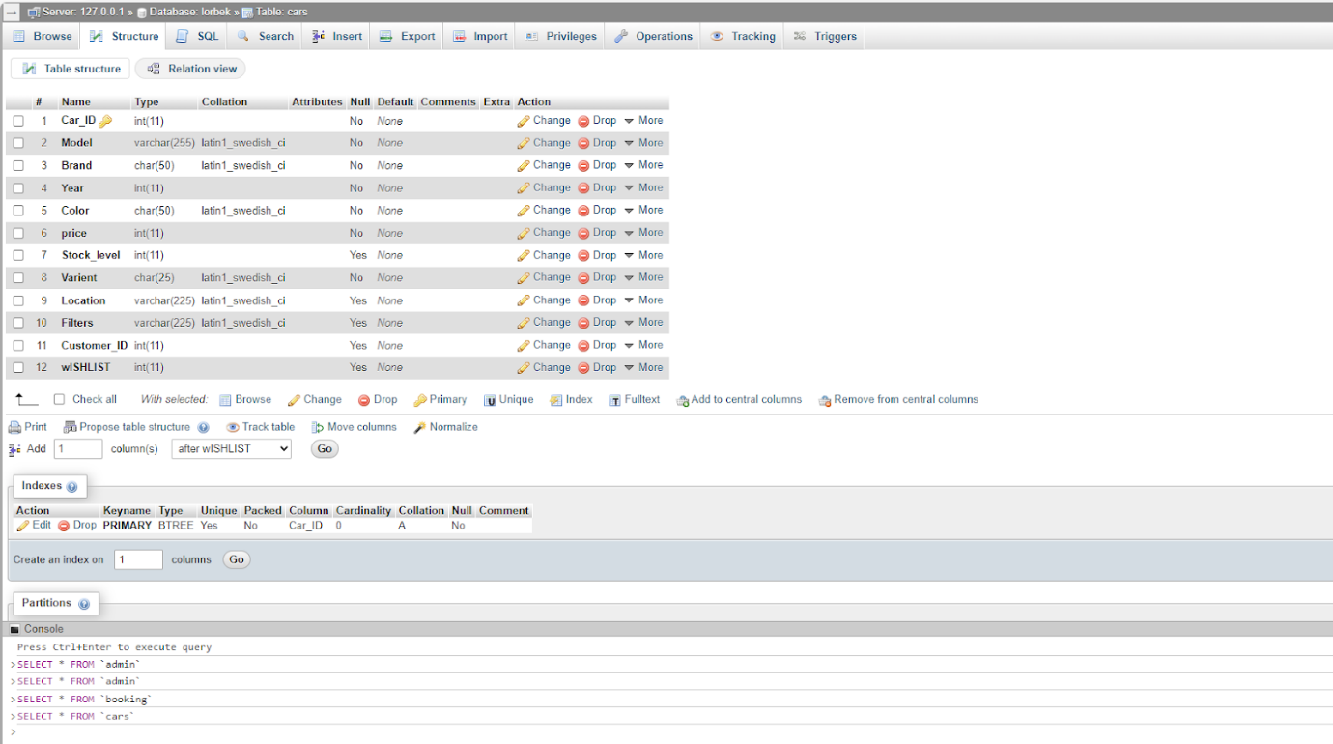

Fig: cars

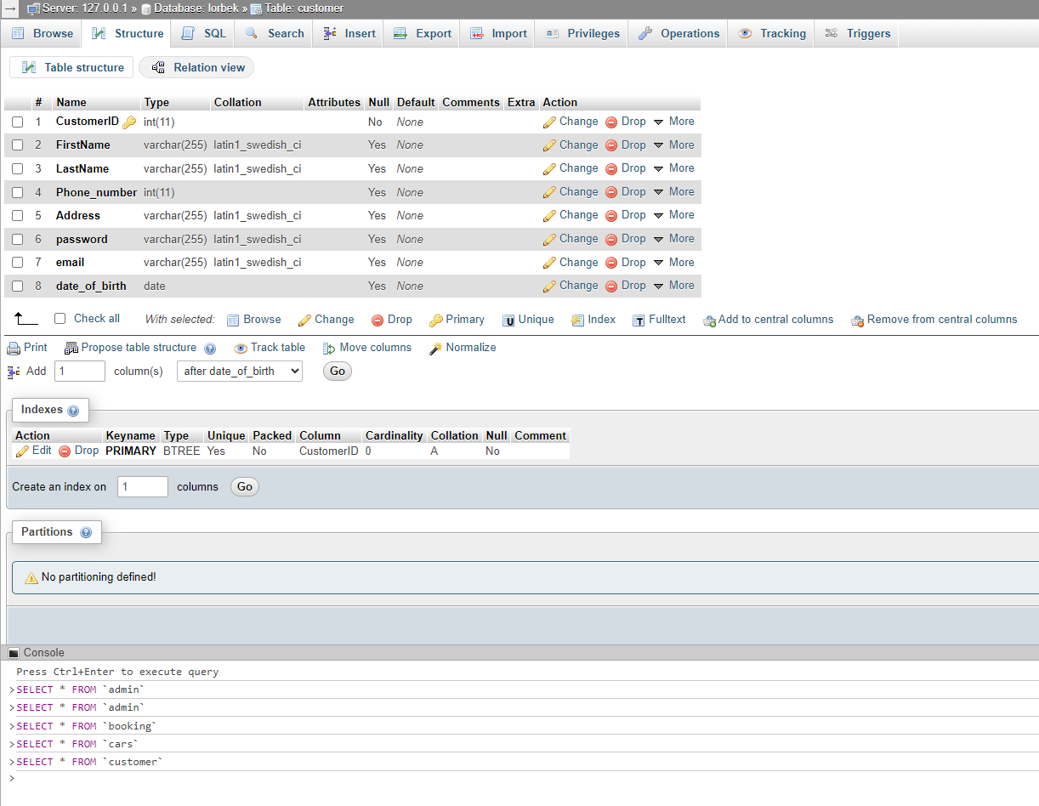

Fig: Customer

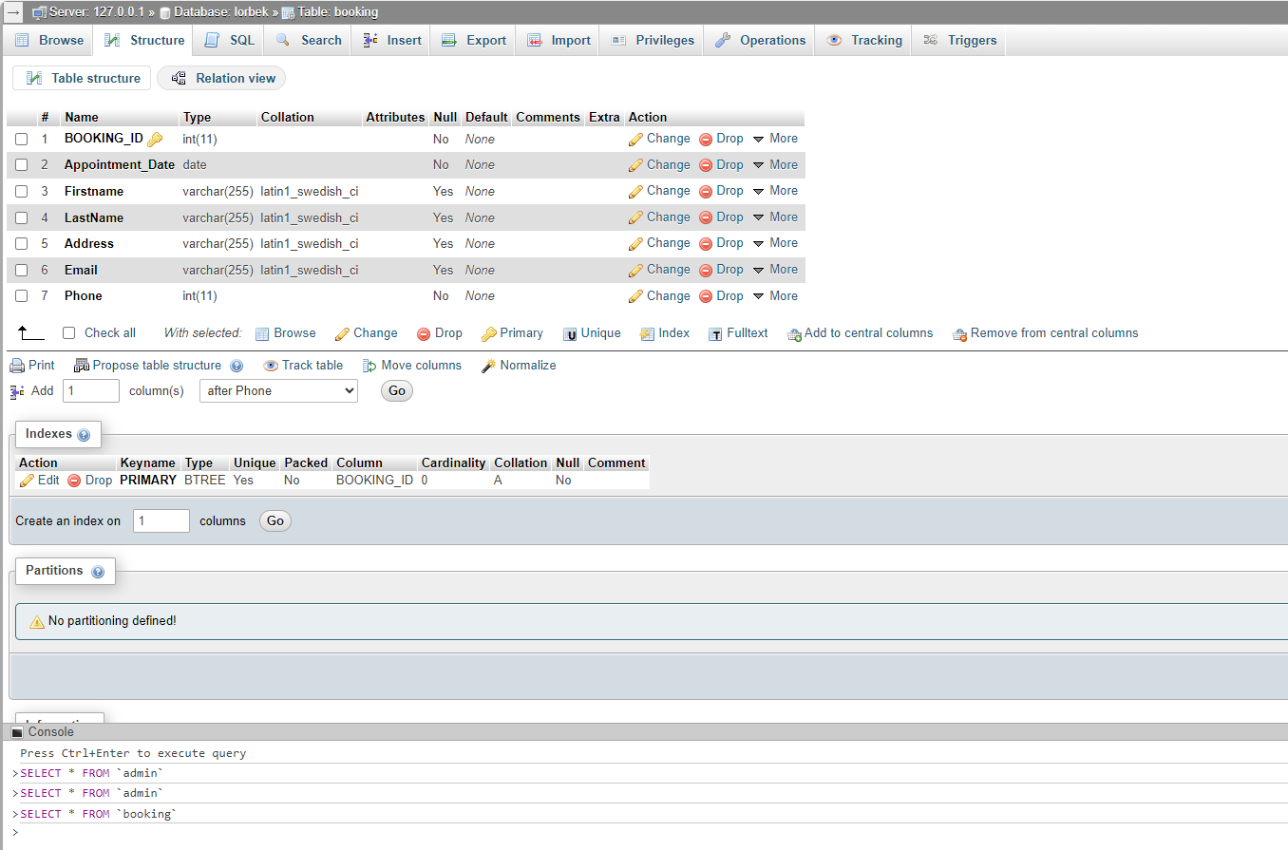

Fig: Booking

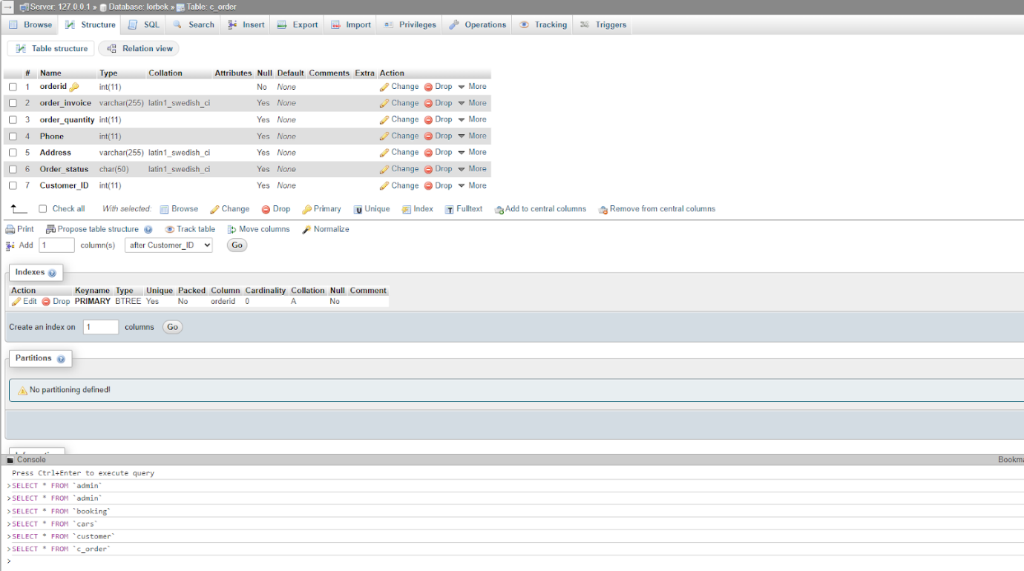

Fig: Customer Order

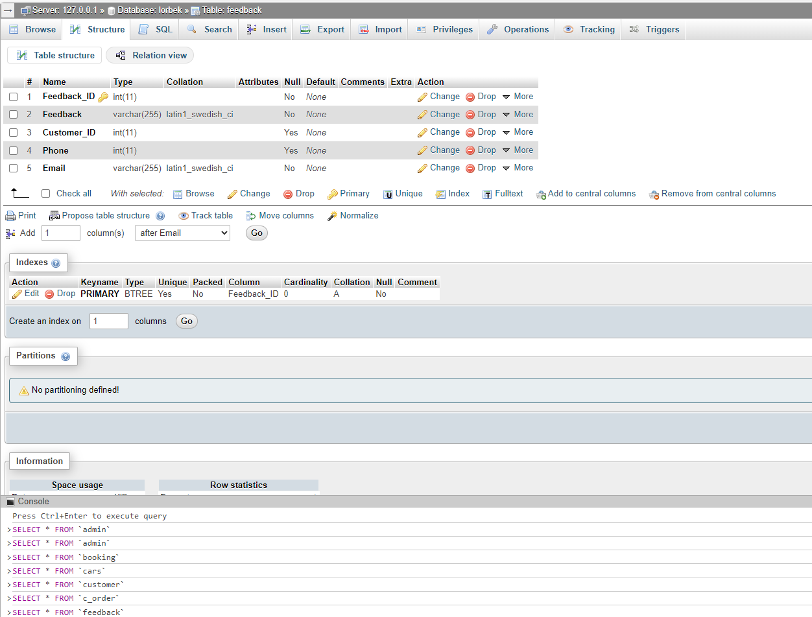

Fig: Feedback